**E-business model based on the relationship of**

**transaction types**

* Business model is ruled by 2 parameters
* **On the basis of value addition :** value addition is the addition of value to a product or service because of the opportunities that if offers on the web.
* **On the basis of control :** high end – hierarchical control
* Low end-no control-self organising.
* Control – through the policies of the website

**9 types of transaction**

1. Brokerage Model 7. Subscription Model

2. Aggregator Model 8. Manufacturer Model

Advertising Model 9. Affiliate Model

3. Info- mediary Model

4. Community Model

5. Value chain Model

6. Subscription Model

**BROKERAGE MODEL**

**Characteristics**

* The price-discovery mechanism: key principle
* It is a meeting point of sellers and buyers
* Auctions and exchanges are the modes of transaction
* It is a “free market”(system in which the prices for goods and services are determined by the open market and consumers, in which the laws and forces of supply and demand are free from any intervention by a government, price-setting monopoly, or other authority.)
* It consists of global network of buyers and sellers
* It is a virtual marketspace enable by the internet
* It encompasses in all types of organisation

**Advantages of brokerage model**

* C2C trading

1. Allows buyers and sellers to trade directly bypassing intermediaries
2. Reduce cost for both the parties

* Global reach
* Trading convenience

1. allow trading at all hours
2. Provides continually updated information

* Sense of community through direct buyer and seller communication
* Efficient access to information
* Alleviation of the risk of anonymous trading

**Brokerage-Price discovery mechanism**

* **Price discovery** refers to the act of **determining the proper price** of a security, commodity, or good or service
* 3 kinds of price discovery mechanisms

1. Auction
2. Reverse auction
3. Market exchange

* Some Examples of price discovery mechanisms:B2B,B2C,C2C

B2B Sell side – fastparts.Com

B2B Buy side – freemarket.Com

B2B Exchanges-covisint.Com

B2C Priceline.com

C2C ebay.com

Indian brokerage site

[www.ebay. in](http://www.ebay.in/) , www.indiacar.com

www.mahindrafirstchoice.com, www.steelexchangeindia.com

**Auction Broker**

* Different auction formats
* Auction in which auction price ascends as auction proceeds
* Auction in which auction price descends as auction proceeds
* Single auctions
* Double auctions

**English Auction**

* One of the **most common auction format**
* Known as **open-outcry auction/ascending price auction**
* Frequently used for selling art, wine, physical goods which **do not have limited lifetime**
* Auctioneer **starts** off the auction with **lowest acceptable** price or **reserve price**
* He receives bids from the bidders until the point from which there is no raise in the bid
* At that point, auctioneer **“knocks down** " the item-highest bidder will receive the item in exchange of money
* Sometimes reserve price will not be made known to public-when auctioneer is uncertain about the price
* Consequence : item will never sold if **the highest bid<reserve price**
* Bidders- anonymous(preserve identity)-if bidding occur through electronic means
* 2 cases
* A **bidder may increase the price expectation** of product-will not beneficial for bidders-but **beneficial for sellers**
* Some **bidders might not join-lower final price for seller**
* *Traditional physical auction*
* Auctioneer influence bidding process
* Manipulate bidders with his voice, gestures and personality
* *Electronic auction*
* Auction site may provide bidders with **alert message** if their bids are too low-service function/manipulative function
* Sometimes bidder get too excited-pays more than actual value or bidder paying less for an item than his valuation to increase his bidding price by small incremental step

**Dutch Auction**

* Developed in netherlands to auction flowers and products with a **limited life**
* Known as **descending price auction**
* **Opening price** is **extremely high**-then descends with **predefined** **amount** at **predefined time *intervals***-until buyer claims the product to be “mine”
* Many items of same product are auctioned-many bidders claim-result in different prices for different bidders-1st person pays highest price
* **Auction time** period is **short**
* Sell fish-england and israel
* Practised in department stores during sale season-dispose excess inventory-discount rate increases
* 2 ingredients

1. Time period
2. Descending price

* Forces the bidder to make bidding decision compared to english auction
* Bidder may bid at/near his actual value

**First Price sealed-bid auction**

* Not being an open-cry auction-thus the individual bids are hidden from other bidders.
* 2 different phases
* A **bidding phase**-All bids are collected
* A **resolution phase**- In which the bids are opened and the winner is determined.
* During the bidding phase, each bidder submits his bid, which is based on his own valuation. The bidder is thus totally ignorant of all the other bids that have been submitted
* In resolution phase all bids are opened and stored from the highest to the lowest bid. If only one item that is auctioned the highest bid will be the winning bid.
* If multiple items of the same product are auctioned, the items are awarded to the highest bids until no more items are left. This is called a Discriminatory Sealed-Bid Auction

**Vickery auction**

* Developed by William Vickery-Nobel prize winner economics(1996)
* Also called Uniformed second-price auction
* The bids are sealed and each bidder bids from his own intuitive knowledge ignorant of all the other bids.
* Difference compared to first-price sealed-bid auction is that, the winning bidder will pay the price of the second highest bid, which is the same as the highest unsuccessful bid. Thus the bidder pays less than what he has bidden.

**Economic Rationality Behind Auctions**

* From a market microstructure perspective, auctions are basically trading process which brings buyers and sellers together.
* Auctions may be used when trading procedure failed to work or when a price discovery process is needed.
* Two main motives for auctions are identified from an economic point of view:
* **Auctions as a mechanism to determine a price.**
* **Auctions as a distribution allocation mechanism**.

**Auctions as a mechanism to determine a price.**

* It identifies auction as a procedure to establish an equilibrium market price.
* It includes product that are not traded on the traditional markets, like rare antique items, or for products with highly fluctuating prices, like stocks, currencies and commodities.
* The common identifier for these auctions is that buyers and sellers are brought together to provide purchase and sale orders and hence liquidity.

**Auctions as a distribution allocation mechanism.**

* Auctions for consumer products which are difficult to sell through the ordinary market channels because they are,
* Products with limited life, such as airplane seats (which are worthless after the plane has taken off).
* Overstocked products which need to be separated from the new incoming products.
* The auctioneer’s main goal is to attract as many customers as possible, so that the market will be liquid without forcing the auctioneer to do major price reductions.
* Attract bargain hunters who are well-informed customers and who know what specific products they are looking for.

**Role of Buyer, Seller And Auctioneer**

|  |  |  |
| --- | --- | --- |
| Auction group | Price discovery mechanism | Distribution allocation mechanism |
| Buyer | To determine an equilibrium price to acquire rare items at a reasonable price. | To make bargain, to acquire products at low price. |
| Seller | To determine an equilibrium price, to find a customer base rare items. | To off load excess inventory, to sell products with limited life. |
| Auctioneer/ intermediary | To achieve high trading volumes, which will lead to high returns. | To achieve high trading volumes, which will lead to high returns. |

**Impact of the web on electronic auctions**

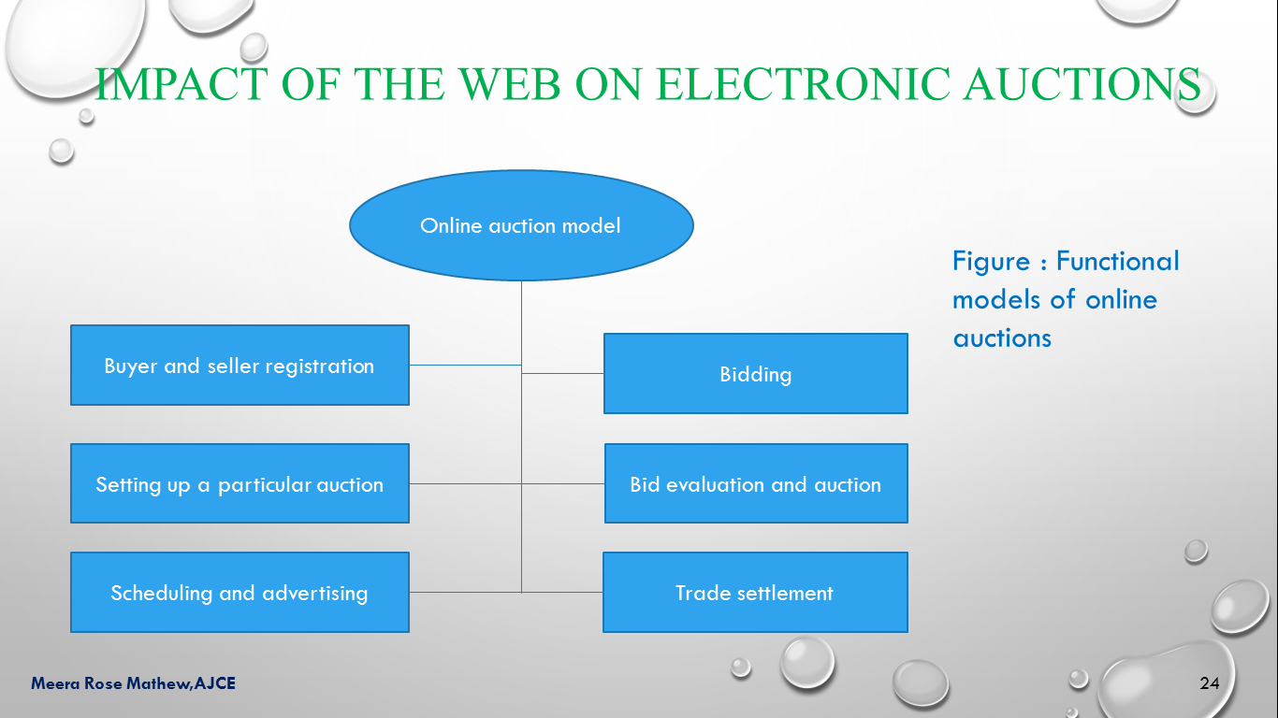

**Impact of the Web on Electronic Auctions**

* The electronic auction can benefit from the following web related features:

1. Common infrastructure with millions of potential users, which increases the possibility of n auction to occur between potential suppliers and customers.
2. Standardized hypertext protocol for displaying the trade objects(ie. Items to be auctioned), which increases the economic feasibility of the electronic auctions.
3. Development of standardized search functions, which help suppliers and customers to find each other.
4. Standards for secure payments(eg. SSL and SET(Secure electronic transaction (SET) is a system for ensuring the security of financial transactions on the internet)), which encourage suppliers and customers to actually use the web medium for trading

* **Critical factors :** Four main factors that characterize electronic auctions:

1. *Perishability.*

Eg. : Flight ticket

1. *Scarcity.*

1. This occurs when there is an excess demand. Eg. New computer parts, domain names, ip address, collectibles (stamps, coins, wine) , communication frequencies.

3. *Goods that may be moved electronically.*

These goods have a great possibility of appearing in the electronic markets. In terms of electronic auctions, securities are one of the most promising areas where an electronic auction may occur.

4. *Goods* *that are geographically constrained.*

If the transportation cost exceeds the customer’s local search cost , the customer will not engage in an electronic auction

* ***Electronic auction seller-buyer perspective:*** Different types of buyers and sellers that appear in electronic auctions

1. Consumer to consumer (C2C)
2. Business to consumer (B2C)
3. Business to business (B2B)

* **Consumer-to-Consumer** represents in an electronic auction, the modern version of classified advertisements.
* Auction will require the two persons to be located somewhat near each other, so that the transportation cost does not exceed the local search cost.
* **Business-to-Consumer** can be identified with companies trying to sell off excess stock or fixing prices for new products.
* Thus the B2C auction will have at least one of the perishability and scarcity market factors.
* **Business-to-Business** auctions are mainly used by companies and governments to sell public contracts and surplus property.
* B2B auctions are to some extent privately held since, only business companies can qualify as potential buyers.
* Therefore, B2B auction sites tend not to be as vigorously promoted to the general public as C2C and B2C auction sites are.

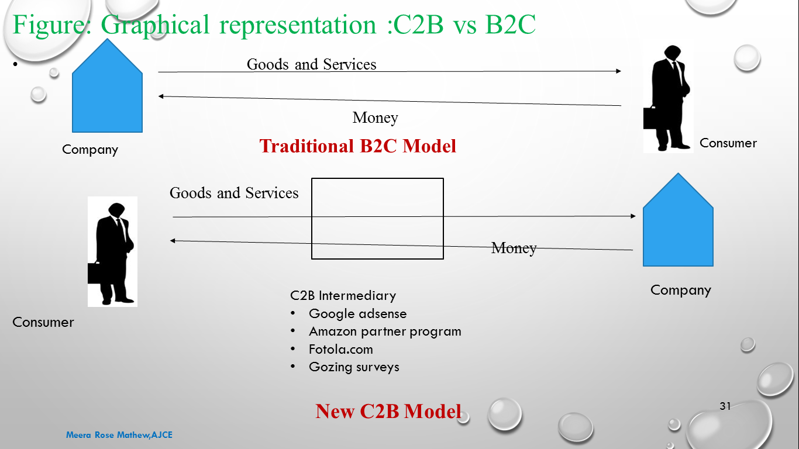

**E-Government**

* E-government refers to the use of information and communication technology to provide and improve government services, transaction and interactions with citizens, business, and other government agencies.
* E-Government Classification
* G2C
* G2G
* G2E
* B2G
* **Government-to-Citizen(G2C)-** the online non- commercial interaction between local and central governments and private individuals. Eg. IRS, FirstGov, etc
* **Government-to-Government(G2G)-**the online interaction between Government organizations, departments and authorities and with other government organizations, departments, and authorities. Eg. Northeast Gang Information System(NEGIS)
* **Government-to-Employees(G2E)-** The online interaction between government organizations and its employees. Eg. Egovonline.com
* **Business-to-Government(B2G) or Government-to-Business(G2B**) –Business and government agencies can use central web sites to exchange information and do business with each other more efficiently than they usually can off the web. Eg. Gov.com

**eBay(C2C)**

* World’s largest online trading community.
* eBay created a new market, an efficient one-to-one trading system in an auction format on the web.
* eBay community is made up of individual buyers and sellers who visit the site to do more than just buy or sell.

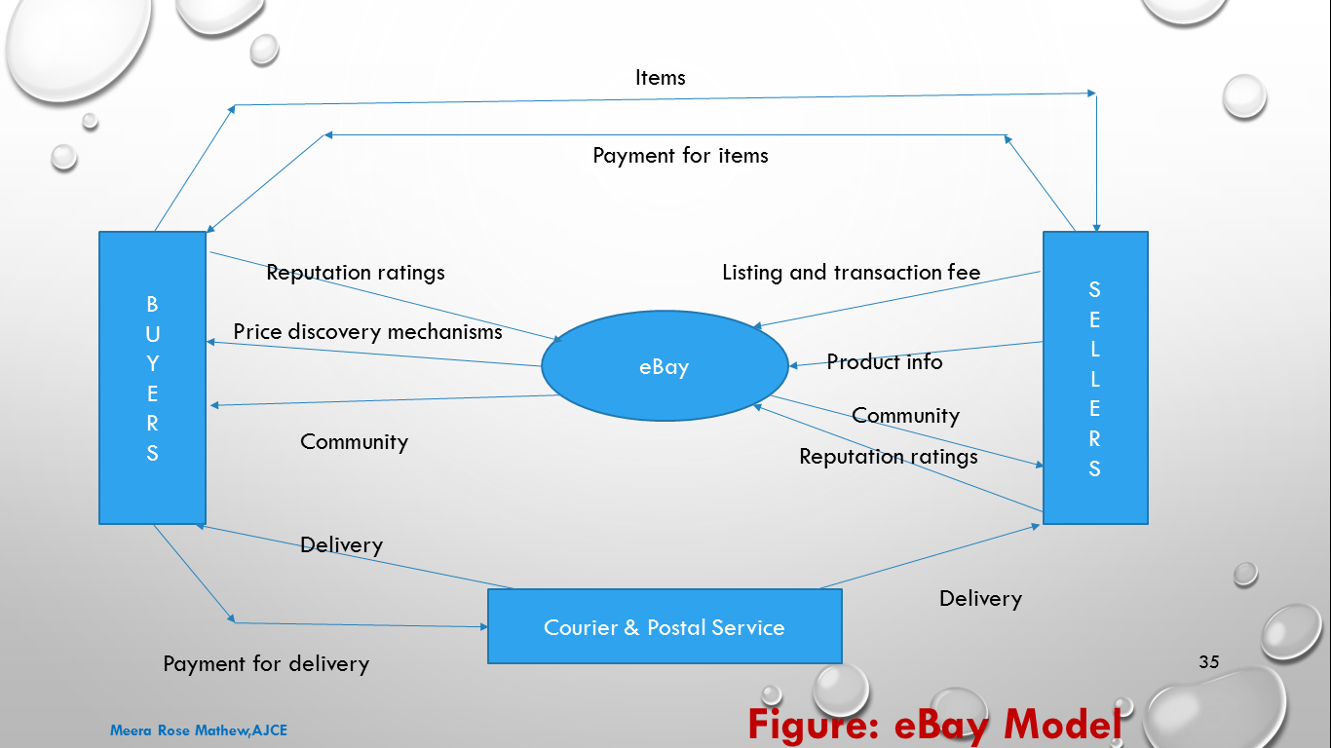

**Reverse Auction**

* The reverse auction business model is described on the priceline website.
* Priceline.com has pioneered a unique type of e-commerce known as a “Demand Collection System” that enables consumers to use the internet to save money on a wide range of products and services while enabling sellers to generate incremental revenue.
* Using a simple and compelling consumer proposition- “name your price”, they collect consumer demand for a particular product for service at a price set by the customer and communicate that demand directly to participating sellers or to their private database.
* Consumers agree to hold their offers open for a specified period of time to enable priceline.com to fulfil their offers from the inventory provided by the participating sellers.
* Major source of revenue are:
* Airline ticket reservation services
* Hotel ticket reservation services
* New auto purchasing
* Home financing, including mortgages, refinancing, and equity loans
* Adaptive marketing programs.
* Licensing patents

**Aggregator Model**

* Classic wholesalers and retailers of goods and services are increasingly referred to as “e-tailers”
* Sales can be made based on list prices or through auctions. In some cases, the goods and services are unique to the Web and do not have a traditional “brick-and-mortar” storefront(Figure)

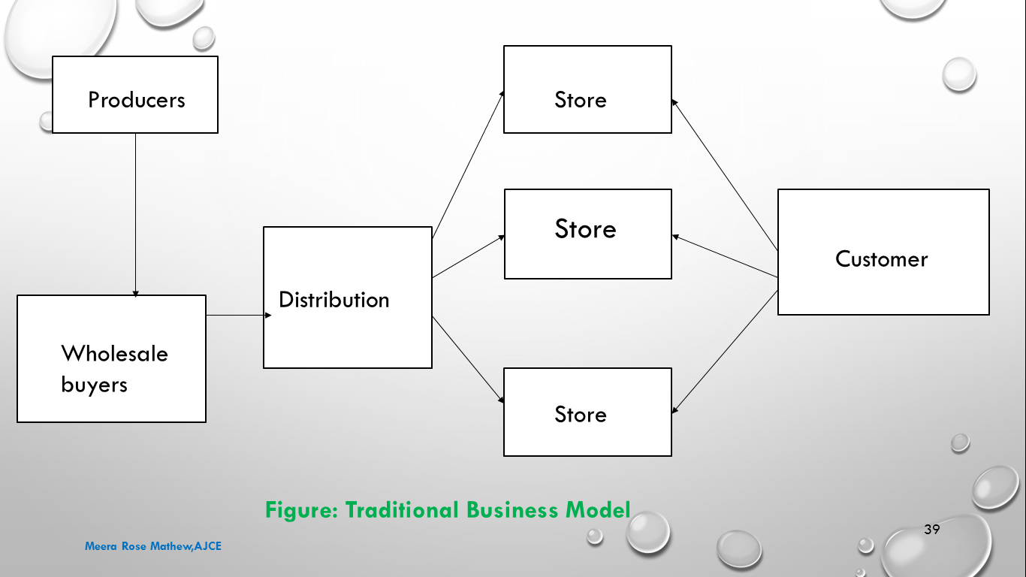

**Some Aggregator Models**

1. **Virtual Merchant**

* This is a business that operates only from the web and offers either traditional or Web-specific goods and services.
* The method of selling may be by list price or auction
* An example of a service merchant is *Facetime*, which calls itself an “*application service provider”*. It offers live customer support for e-commerce websites(Eg. Amazon,eToys,Eyewire and OnSale)

1. **Catalogue merchant**

* Catalogue merchant is the migration of mail order to a web-based order business(Eg. Levenger)

**3. Surf-and-Turf**

* This is a traditional brick-and-mortar establishment with Web storefront.
* The model has the potential for channel conflict.

**4. Bit vendor**

* This is a merchant that deals strictly in digital products and services and in its purest form, conducts both sales and distribution over the Web.

**5. Subscription Model**

* In this users pay for access to the site. High value-added content is essential. Eg. WallSt. Journal, ConsumerReports
* Generic news content, viable on the news-stand, has proven less successful as a subscription model on the Web(Eg. Slate)

**What Do Aggregator Do?**

* Based on the electronic marketplace, the aggregator model bypasses distributors so that the buyers and sellers come together.

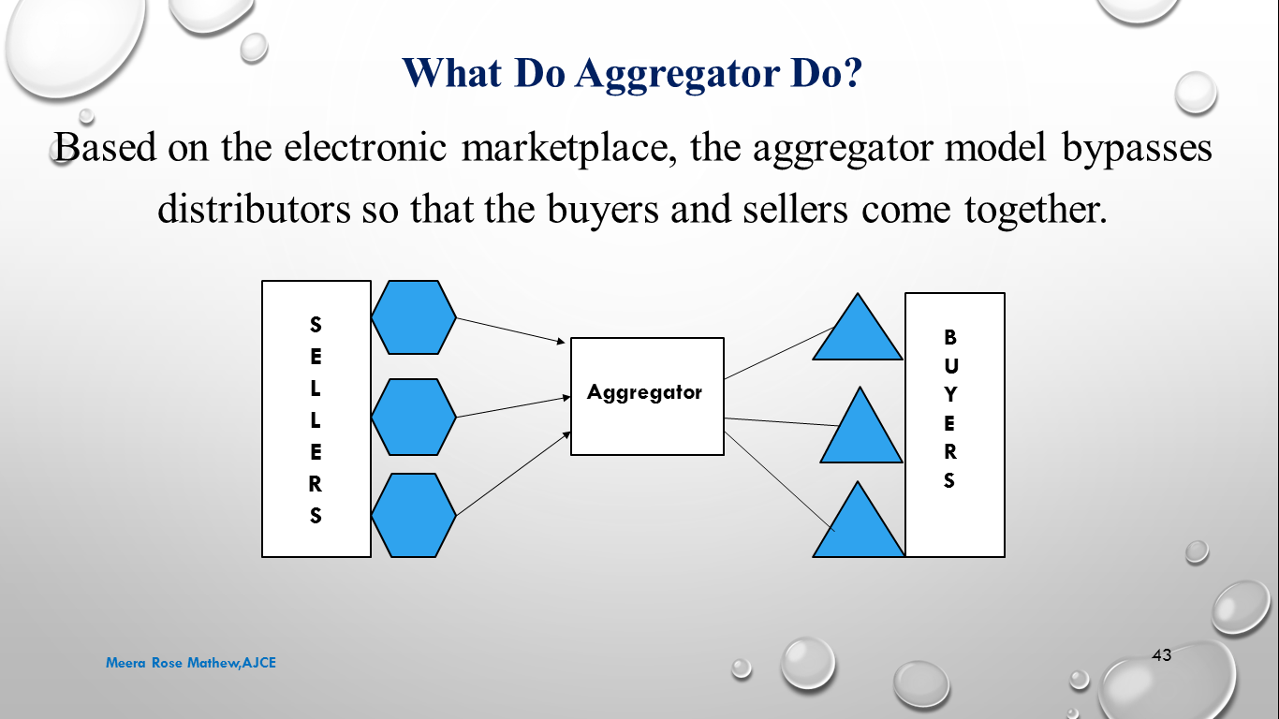

* The aggregators are the connectors between the buyers and the sellers
* They are involved in the overall process of ***selection, organization, matching the buyer’s requirement*** with the particulars of the available goods, ***fulfilment of the orders*** and enabling the customers to create a value about the sellers.
* Four types of Aggregators

1. ***Content Aggregators***
2. ***Mainstream aggregators***
3. ***Event Aggregators***
4. ***Shopping Aggregators***

**1. Content Aggregators**

* They are among the first large-scale sites on the Web and mostly represent large publishing companies, Eg. Pathfinder.com
* Their basic challenge is that content has to be attractive enough to make the site viable.

Eg. **CANOE and Hockeyplus,** that provide extensive statistics, analysis, pool information

**2. Mainstream aggregators**

* These includes sites like Yahoo providing a Web directory and a search engine, along with a bunch of attractive tools like e-mail addresses, home pages, reminders, and many others
* The most attractive feature is that they have an ‘easy-to-remember’ URL which is one of the reason for them to be the top traffic sites on the web.

**3. Event Aggregators**

* These are the sites that provide in-depth content and tools tailored to the needs of a particular group, which doubles as a clearly defined customer base,

Eg. Mortgages– build tools, rates, advise, and the ability to purchase a mortgage online in the same place(Microsoft’s HomeAdvisor or HomeShark)

**4. Shopping Aggregators**

* Shopping Aggregators let consumers roam through hundreds of sites and catalogues and find the best price in seconds.
* They help consumers sift through dozens of e-commerce sites

Eg. compare.com and bizrate.com evaluate their quality on independent basis as in the case of consumer reports

* E-commerce is forcing changes in the distribution channels that require all parties- manufacturers, distributors, retailers, consumers and logistics companies – to evaluate their value proposition and develop capabilities that will meet the evolving demands of the Internet age.
* Implications for manufacturers, other challenges and opportunities of e-commerce are:

1. Requires investment in marketing directly related to the consumers so as to sustain consumer loyalty to their brands
2. Relies on consumer’s support for the sale of products
3. Requires brick-and-mortar enablers to function as a distribution centre for local delivery and returns, and for regular retail activity

**INFO-MEDIARY MODEL**

**Info-Mediary**

* An organizer of virtual community who helps sellers to collect, manage, and maximize the value of information about consumers is called an information intermediary or info-mediary.
* Data about consumers and their buying habits are extremely valuable, especially when that information is carefully analysed and used to target marketing campaigns.
* Some firms are able to function as info-mediaries by collecting and selling information to other businesses
* An info-mediary may offer users free internet access(eg.Netzero) or free hardware (eg.Emachines.Com) in exchange for detailed information about their surfing and purchasing habits.

**Figure: Info-mediary Model**

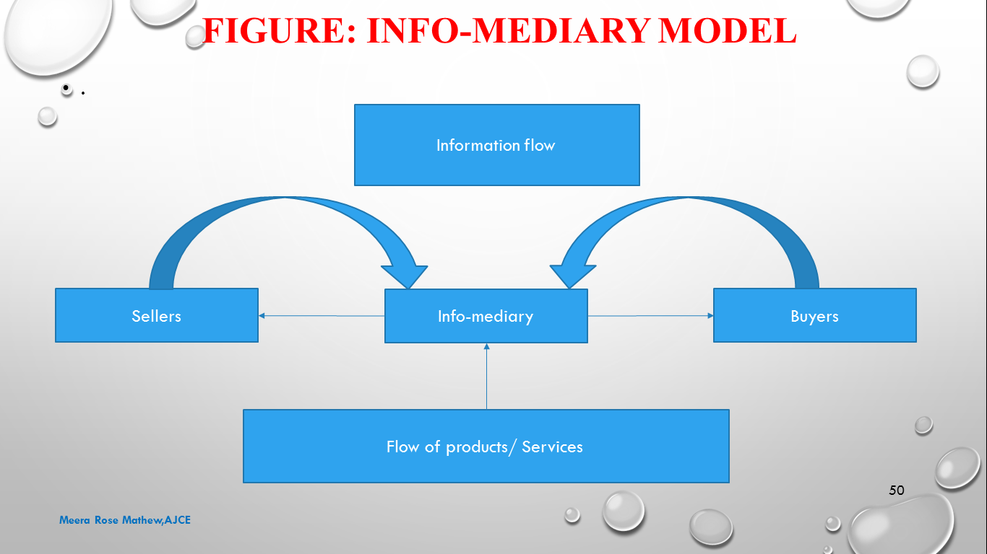

**Info-mediary model**

* The info-mediary model can also work in the other direction, ie, providing consumers with useful information about the websites in a market segment.
* Info-mediaries are in information business, implying that they competes on their ability to capture and manipulate information in a manner that adds value for their clients, who could be seller or buyers.
* A real info-mediary provides information services by capturing information from both sides of transaction.
* They do not own the products or services that are shipped directly from suppliers to customers
* Source of revenue:
* Deeper pockets on the seller side
* Membership fees for participating in an electronic market
* Advertising revenue: accepts payment from suppliers based on advertising space, number of user page views, and transactional revenue
* Buyer based revenue : characterized by increasing choice, complexity, and information overload (subscription fees).
* Allowing access to valued information or services,
* Transaction percentage
* Fees based on services such as connecting a seller to a buyer and ensuring privacy protection

**Value Addition**

* Info-mediaries create and add value for the customer during several critical phases from the initial search of the supplier and product comparison(as to whether it fulfils the requirement) to the actual transaction and ultimate product or service delivery(sales fulfilment).
* Info-mediaries leverage the potential of the internet to provide almost unlimited expansion of search space for consumers, thus overcoming the limitation of physical space inherent in traditional brick-and-mortar operations
* Info-mediaries aggregates a large number of suppliers saves buyers invaluable hours on tedious piecemeal searches through direct use of search engines.
* Info-mediary provides valuable assistance to buyers to make their purchasing decisions, by offering “suitable” suggestions.

**Classification of info-mediaries**

* Relationship types
* Non-proprietary / open : giving anyone free access
* Proprietary / closed : restricting access
* Based on their relationship between buyers and sellers info-mediaries are classified as,

**A. Specialized agents**

* Closed relationships between buyers and sellers
* Their business performance depends on their ability to deliver value through scope(sufficient numbers of buyers and sellers), specialization(a well-defined), and infrastructure(a platform for transactions)

**B. Generic agents**

* Open relationship with both buyers and suppliers and involve no relationship-specific investment.

**C. Supplier agents**

* The sustainability depends on the quality of suppliers they include, provision of benefits to buyers, and the ability to maintain a good infrastructure and seamless exchange platforms

**D. Buyer agents**

* Establish a relationship with a core set of buyers, working on their behalf and any number of suppliers

**Evolution of info-mediaries**

* Early info-mediaries were sponsored by a seller or a group of sellers wanting to participate in the e-commerce environment, where it is in the agent’s best interest to sell the supplier’s products.
* Their affiliations with suppliers are strong but weak with buyers, who may not value a biased market of limited scope.
* A large supplier base naturally reduces the affiliation of the info-mediary vis-à-vis(in relation to; with regard to.) The few original sponsors.
* Doesn’t compete on margin but on its ability to deliver information and provide navigation and other value added services to buyers
* It might therefore expected that info-mediary evolution will be towards greater buyer affiliation and buyer sources of revenue

**Some examples of info-mediary**

1. Typical of generic agents, yahoo.com provides comprehensive search facilities for both buyers and suppliers.
2. In response to the information explosion challenge for the chain-pharmacy industry, chaindrugstore.net entered the B2B marketplace as a state-of-art “info-mediary” hub and the wholly-owned subsidiary of the NACDS.

**COMMUNITY MODEL**

**Community:**

* A unified body of individuals
* (B) the people with common interests living in a particular area
* An interacting population of various kinds of individuals in a common location

**Community model**

* E-communities are formed when groups of people meet online to fulfil certain needs, which include personal interests, relationships, entertainments and transactions.
* They are not confined to just individuals but business as well.
* E-communities cater to groups of people who come online to serve their common interests and needs, exchange information, share interests, trade goods and services, entertain and, seek help
* The community model may also run on a subscription fee for premium services.

**Functions of communities on the web**

1. Most people long to be accepted and loved and concerned about. These along with a desire to learn cause communities to attract people. Word goes around about a discussion going on or about a place to make personal or business contacts, and visitors thus are attracted. They may end up joining the community.
2. Communities on the internet provide information. Since they tend to revolve around a particular interest or common task or hobby, they can be the sources for sharing information, and can become deep reservoirs of technical information.
3. Communities also beget loyalty. Members develop the habit of visiting one particular site again and again. They got so used to the site, that they develop a sense of ownership, especially if they are involved in online communication.
4. Communities also build your business. Once people become used to a site, they are quite comfortable making a purchase through it rather than going into unknown territory.

Community structure

The Internet communities can be found several predictable ways

Newsletters

Discussion lists

E-mail discussion list

E-mail discussion list digest

Moderated discussion list digest

Bulletin boards

Keeping threads separate

Allowing posts to be read, searched, and researched later by individuals who may not have been part of the original conversation.

Chat rooms

Open source

Open content

Public broadcasting

Social networking services

Necessary elements for the community model

A clear focus for the community that makes sense to prospective members

The requisite technical capability through your own software and hardware or a free service

A proper structure, guidelines, and parameters for the discussion to keep the group on target

A moderator responsible for each group or list

A clear strategy on how the community will benefit your business. Since communities care a lot for maintenances, it has to achieve something to make it worth your while.

What effects can you expect a community to have on your business’s profit and loss statement?

Customer satisfaction through effective customer support is difficult to reckon with, although the availability of customer support will make the product or service more attractive. And therefore enhance sales

Increased traffic leads to increased publicity. Participants or visitors to the site will circulate the word around, and news media will write stories about the site.

Repeated use will develop loyalty among the users towards the site

Moderating or sponsoring a group puts you in the role of an expert in the industry, and gives you and your business high visibility

Narrowly focused groups you sponsor (those who have a clear interest in your product or service)

When your list is well developed you can earn some advertising revenue from e-mail ads or banner ads, but do not start a list expecting this to be your primary revenue stream – it probably will not develop this way for at least a year or two, if at all

Value chain model

Value chain moves business away from discrete streams of data about the product being made to one unified pool of information- one that even extends outside the company to suppliers and customers.

The goal is to develop full and seamless interaction among all members of the chain, resulting in lower inventories, higher customer satisfaction, and shorter time to the market.

Generalized Portal: AltaVista as a Value Chain Model

AltaVista Company is the premier knowledge resource on the Internet.

With its strong search engine tool and patented technology, AltaVista opens up avenues in the maze of Internet to the richest and the most relevant information on any subject from any nook of the web world, web pages, shopping, up-to-the-minute news, live audio and video, and community resources.

AltaVista provides distinct internet experience through multiple integrated platforms as:

AltaVista search : World’s fastest, most comprehensive search service available in 25 languages with 8 distinct search dimensions

AltaVista shopping.com : First Web-wide comparison shopping service on the Internet

AltaVista live! : The only real-time, customizable content source on web, linking content channels on topics such as money, news, sports, entertainment

AltaVista raging bull : The Web’s stickiest site, which has the Web’s most active community of message boards, with an emphasis on finance.

AltaVista free access : One of the fastest growing ISP services in the world, with over 2 million registered users in the US and Canada

AltaVista international : Currently over half of its traffic comes from outside the US.

The portal gives the website owner access to online traffic reporting through reporting. Therefore the owner can access how effectively his affiliate network site is marketing AltaVista's products.

Latest AltaVista search technology

Search catalogues, inventory databases, auctions, classifieds, job listings, and even suppliers.

Improve the success rate of incoming searches

Allow users to sort results by brand, price, availability, or any method

Personalized portal: My Yahoo! As a value chain model

My Yahoo! Is the users own personalized version of Yahoo!

After the user gives his personal information, My Yahoo! Allows him to collect all his favourite sections of Yahoo! in one place.

He can choose what he wants to surf, such as news, weather, stock prices, sports scores, TV and movie listing, horoscopes

My Yahoo! Is absolutely free.

Some topics that Yahoo! Offers:

Pick your weather cities.

Track your stock quotes

Read your choice of news

Find local movie show times.

Follow your favourite sports teams

Manufacturer model(Direct Model)

Is predicated on the power of the web to allow a manufacturer to reach buyers directly and thereby compress the distribution channel.

It can be based on efficiency, improved customer service, and a better understanding of customer preference.

The manufacturer sells its products through the use of its website.

Purchase : The sale of a product in which the right of ownership is transferred to the buyer

Lease : In exchange for a rental fee, the buyer receives the right to use the product under a “terms of use” agreement. The product is returned to the seller upon expiration or default of the lease agreement.

Licence : the sale of a product that involves only the transfer of usage rights to the buyer, in accordance with a “terms of use” agreement. The ownership rights remains with the manufacturer(Software licensing)

Brand integrated content : In contrast to the sponsored-content approach, brand integrated content is created by the manufacturer itself for the sole basis of product placement

Tata steel : e-business, e-sales, e-procurement, e-auction and tendors

Advertising model

Is an extension of traditional media broadcast model.

The broadcaster, in this case a website ,provides content and services(e-mail,chat,forums) together with advertising messages in the form of banner ads.

The banner ads may be the major or sole source of revenue for the broadcaster.

The broadcaster may be a content creator or a distributor of content created elsewhere.

The advertising model only works when the volume of viewer traffic is large or highly specialized.

Advertising-driven sites are currently one of the cornerstones of e-commerce.

A site offers free access to something and shows advertisements on every page.

When a user click on an advertisement, he goes to an advertiser’s page.

The advertiser pays the site operator for showing his advertisement(eyeballs) or for every time someone clicks on the advertisement(Click- through)

Eyeballs and click-through

Web pricing models

CPM or impression only(sets cost-per thousand of guaranteed ad views)

Click-through(the advertiser pays based on the number of times the banner is clicked by a user)

Sponsorships(package deals impression and click-through)

Cost-per-lead(the advertiser pays when a viewer registers or submits personal information)

Cost-per-sale(agrees upon charge for the viewers who actually purchase a product or service based on the ad)

Straight revenue sharing deals(the publisher receives a commission which is paid upon sale from an ad)

Types of advertising on the internet

Portals

A search engine that may include varied content of service. Eg. Yahoo!

Classifieds

Lists items for sale or wanted for purchase.Listing fees are common but there is membership fee also. Eg. Monster.com

User based registration

Content-based sites that provide free access to users but require the user to submit demographic details by registration. Eg. Nytimes Digital

Different web advertising formats

Banners : an add appearing at the top of a web page

Vertical columns : on a frame web page positions alongside requested content

Pop-up windows : java script opens a browser window with an ad

Interstitials : full screen ads that appear on a web browser while a page is loading

Advertorials : content based advertising related to an article or other site content

Intromercials :animated full-screen ads placed at entry of a site before a user reaches the intended content

Ultramercials : interactive online ads that require the user to respond intermittently in order to wade through the message before reaching the intended content

Formats that permit more effective ads

Richer ad content through sight, sound, and motion

More information

More interactivity

Larger screen size

More prominent screen position

Less content competition

Reliable measurement and reporting to enable each advertiser to determine its ad

Accurate audience measurement

Meaningful user targeting

Cost-effective advertising model with rates reflecting advertiser value

Subscription model

Users are charged a periodic- daily, monthly, or annual- fee to subscribe a service.

It is not uncommon for sites to combine free content with “premium”(Subscriber or member only) content.

Content services : provide text, audio, or video content to users who subscribe for a fee to gain access to the service. Eg. Netflix.com

Person-to-person networking services : are conduits for the distribution of user-submitted information, such as individuals searching for former schoolmates. Eg.Classmates.com

Trust services : comes in the form of membership associations that abide by an explicit code of conduct, and in which members pay a subscription fee. Eg. Truste.Com

Internet service providers : offer network connectivity and related services on a monthly subscription. Eg. America online

eGurucool.com

Well structured lesson plans that generate interest, curiosity, and provide clarity about objectives that should be achieved through the lessons

Technology is used wherever necessary

Affiliate model

Provides purchase opportunities wherever people may be surfing.

It does this by offering financial incentives (Percentage of revenue)to affiliated partner sites.

The affiliate provide purchase-point click-through to the merchant

It is a pay-for-performance model—if an affiliate does not generate sales, it represents no cost to the merchant.

Variations includes:

Banner exchange : It trades banner placement among a network of affiliated sites.

Pay-per-click : It is the site that pays affiliates for a user click-through.

Revenue sharing : It offers a per cent-of-sale commission based on a user click-through in which the user subsequently purchases a product

The affiliate saves the expense of handling inventory, advertising and promoting th product, and processing the transaction.

Eg. Amazon.com